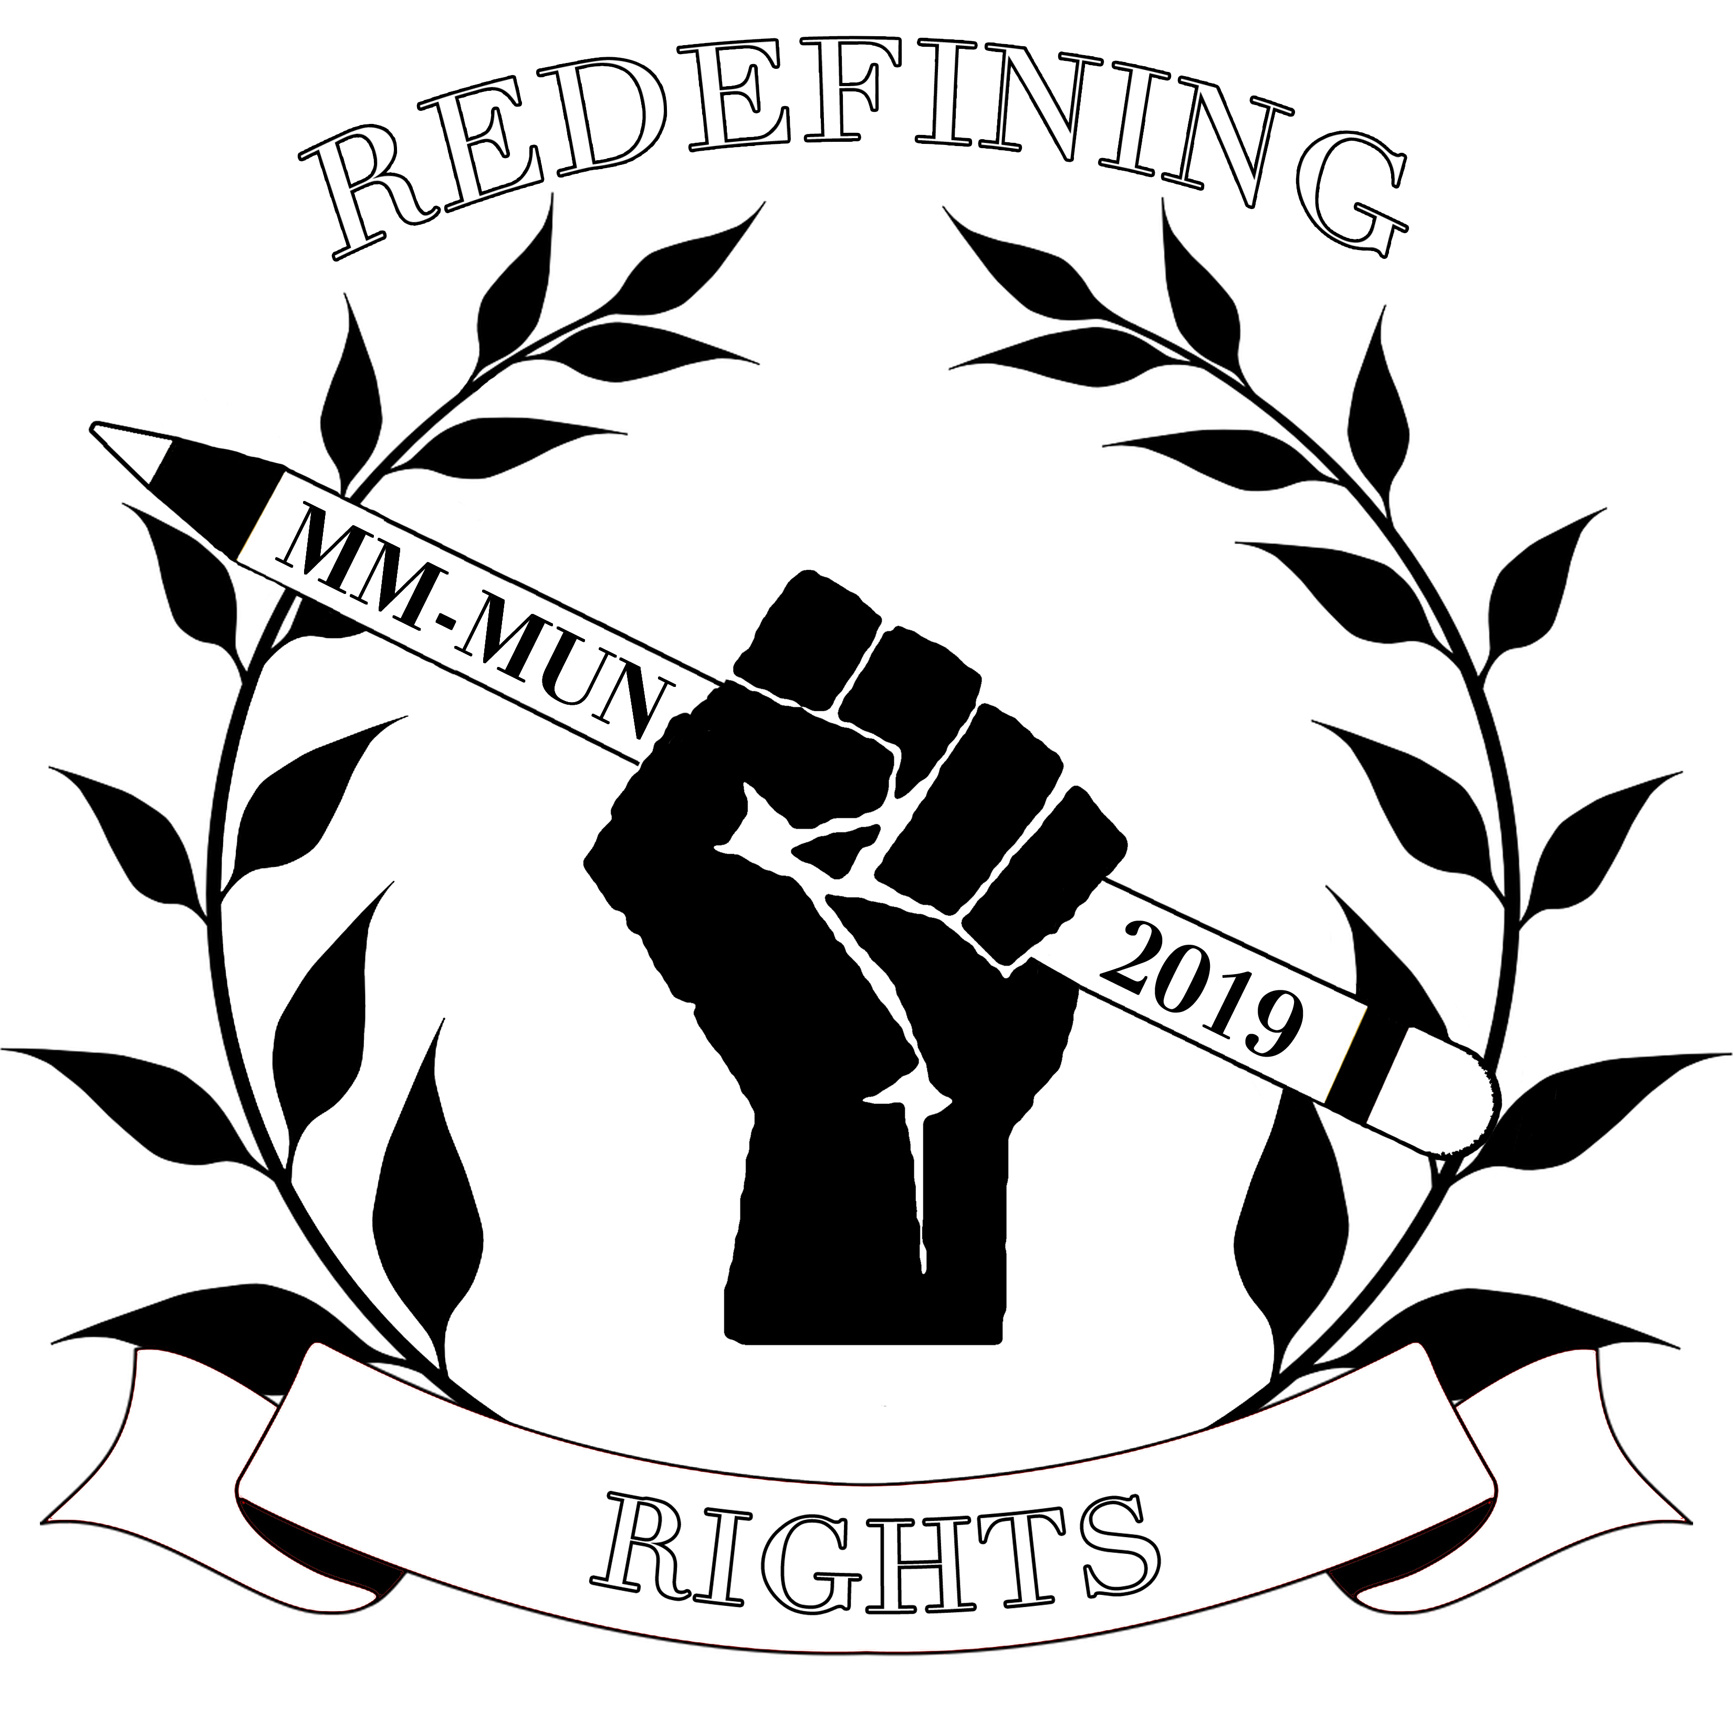

MM-MUN 2019
Marymount High School, Los Angeles
16 March 2019

Conference Schedule

8:00-8:30 AM Registration
8:30-9:00 AM Opening Ceremony
9:00-11:00 AM 1st Committee Session
11:00-11:30 AM Recess with snacks
11:30-1:30 PM 2nd Committee Session
1:30-2:30 PM Lunch
2:30-3:00 PM Closing Ceremony

